To clear cache in **Internet Explorer**:

Step 1: Access the options toolbar (indicated by a gear icon). Step 2: Select “Internet options”.

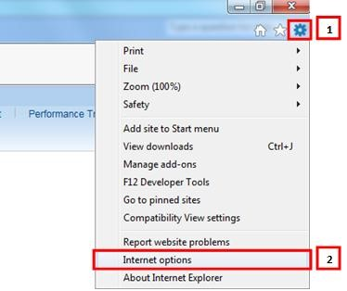

Step 3: Select “Delete.”

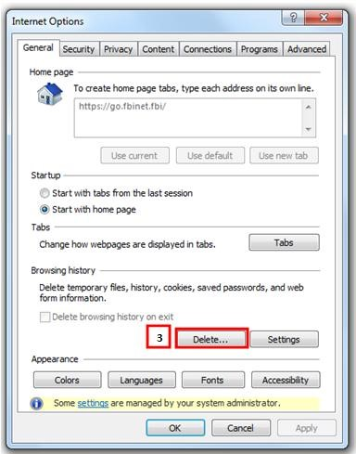

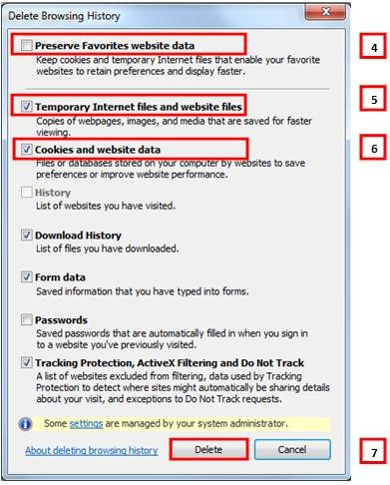

Step 4: Ensure “Preserve Favorites website data” and is unchecked.

Step 5: Ensure “Temporary Internet files and website files” and is checked.

Step 6: Ensure “Cookies and Website data” and is checked.

Step 7: Select “Delete.”

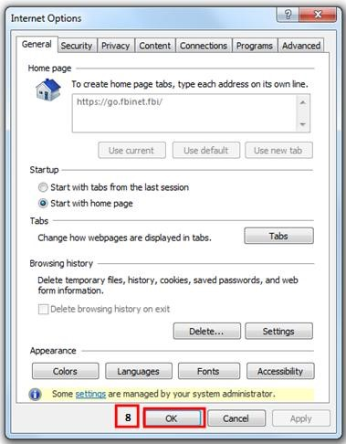

Step 8: Select “OK.”

Step 9: Close the browser and open a new Internet Explorer browser window.

To clear cache in **Firefox**:

Step 1: Access the menu on the top right of the browser (indicated by 3 lines).

Step 2: Select “Options.”

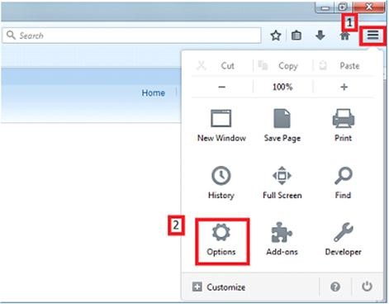

Step 3: Select “Privacy.”

Step 4: Select the “clear your recent history” link.

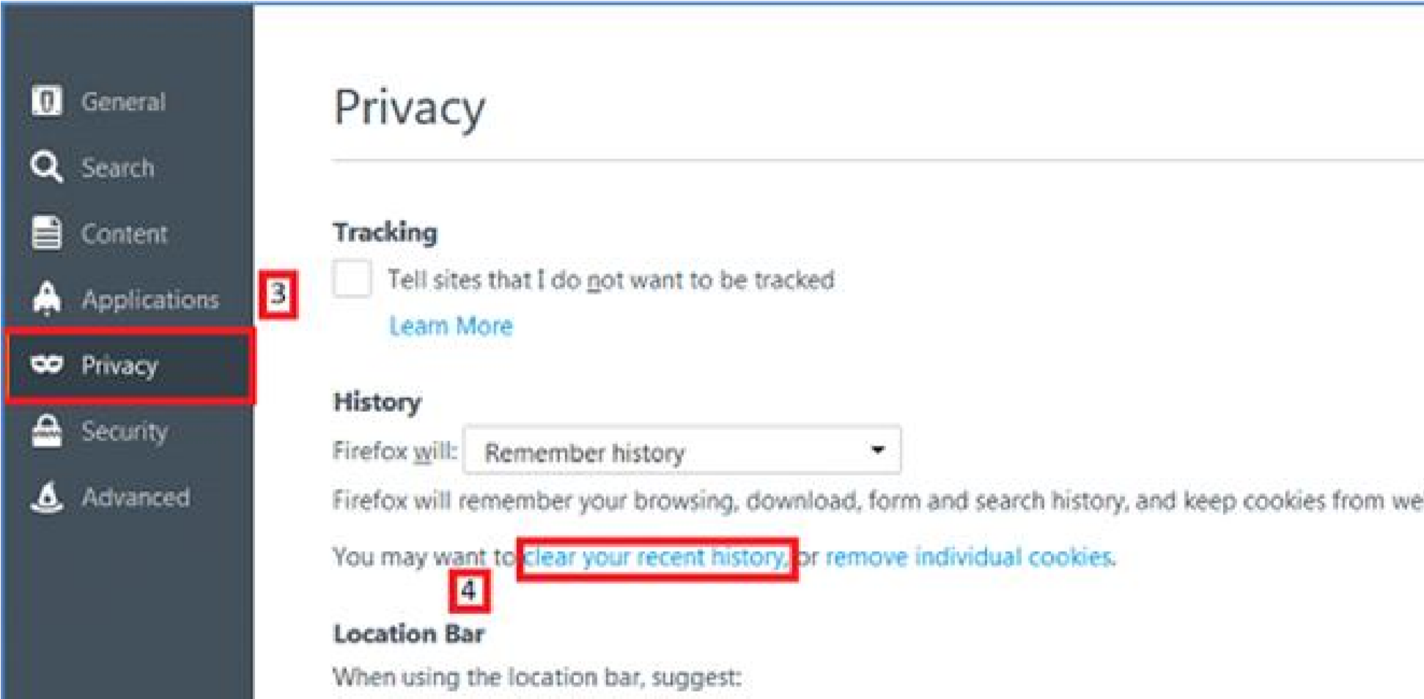

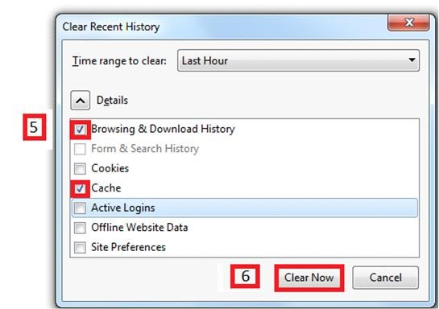

Step 5: Ensure “Browsing & Download History” and “Cache” is selected.

Step 6: Select “Clear Now”.

Step 7: Close the browser and open a new Firefox browser window.